Assignment 1 Kasperi Palkama

356440

Exercise 1/4

* Data is 2D but the graph is 3D (unnecessary depth)
* There are colours without a meaning
* Graph is continuous even though enrolment occurs probably ones a year.
  + Rest of the data is probably just guessing
* Y axis is broken two times
* Plot area is not proportional to the values

Exercise 2/4

Figure 1 is a disturbingly bad example of graphics. It uses with huge scale difference. This creates an illusion that the number of unemployed people is almost the same as the number of open job positions which is completely not true.



*Figure 1. An example of bad graphics.*

Exercise 3/4

1. Figure 2 presents a graphic which Juha can use to convince the public that we are heading a crisis because of the increase of debt.

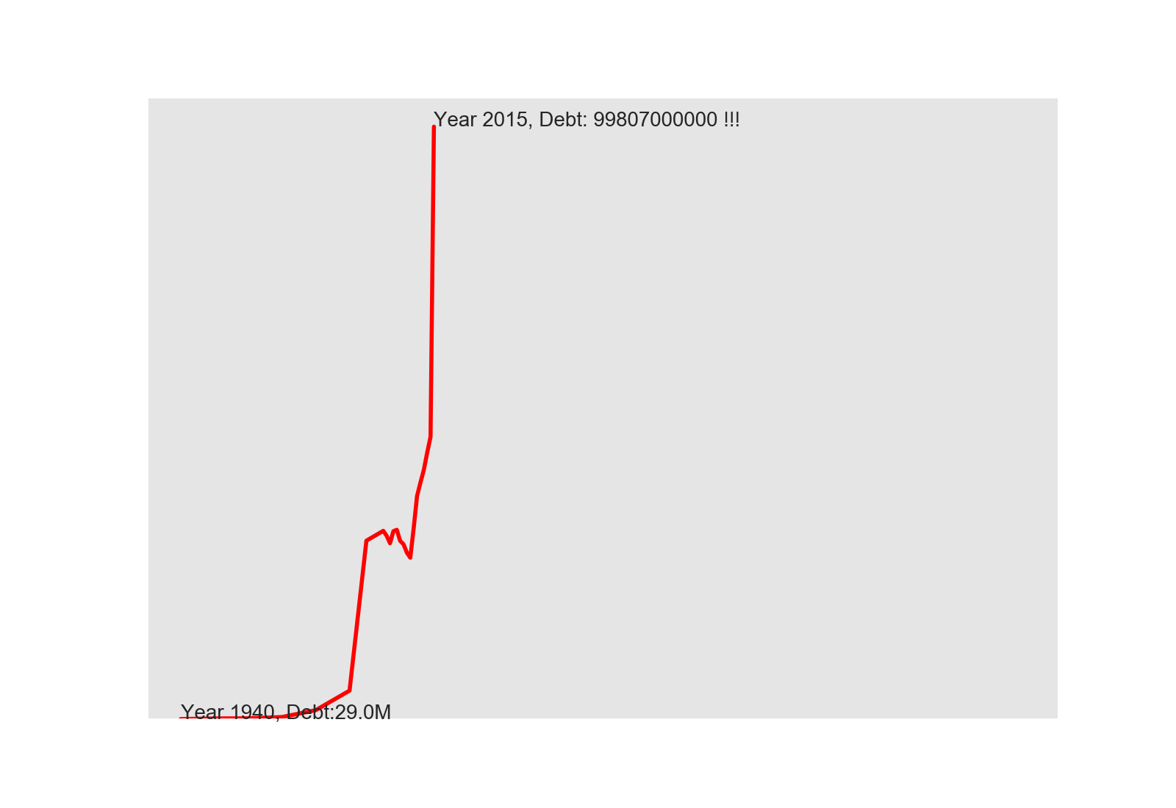

*Figure 2. Graphic to convince the public about incoming crisis*

1. Figure 3 presents graphic to convince the public against Juha’s opinion.

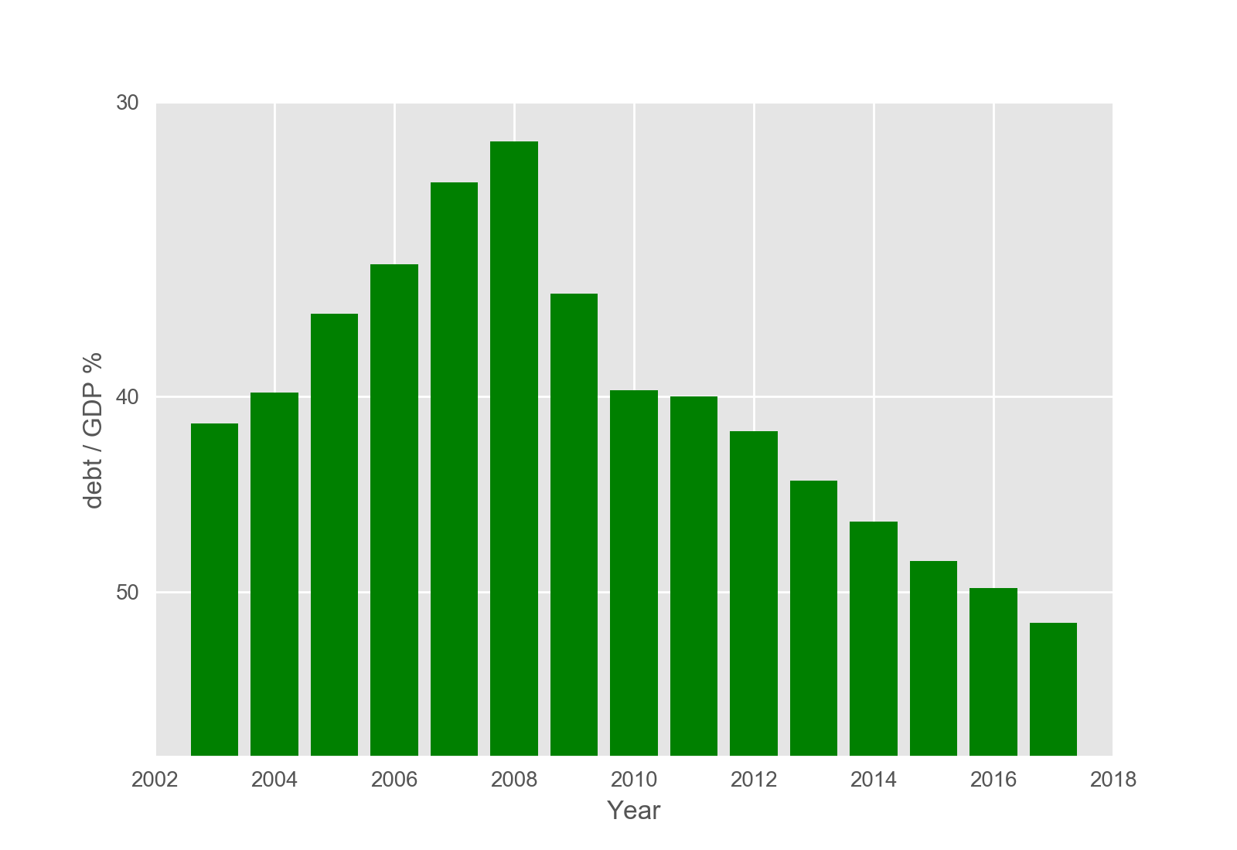

*Figure 3. A proper graphic for Antti to convince the public against Juha’s opinion*

1. LF = relative change shown in graphics / relative change in data

Figure 2: Lying factor between values for the years 1990-2015. 1990 is the on the x-axis at first elbow point in the figure and 2015 is the x-value of the last value.

relative change in graphics = (7 cm – 0.3 cm) / 0.3 cm = 22.33…

relative change in data = (99807 M – 9590) / 9590 = 9.407…

* LF = 22.33… / 9.407… = 2.37…

Figure 3: Lying factor between values for the years 2008-2017

relative change in graphics = (1-5 cm – 6.9 cm) / 6.9 cm = -0.78…

relative change in data = (51.5 – 28-1) / 28.1 = 0.83…

* LF = -0.78… / 0.83… = -0.93…

1. Figure 3 presents graphic following Tufle’s principles. The whole data is showed without doing any tricks to axis. Debt is shown as a percentage of GDP because it is stupid to just look at the amount of data because of the inflation etc. Data-Ink ratio is kept high to transmit only the information in data. Only legend, grids and text are not directly describing data. These could be taken away but I believe they help viewer to understand the data better. 0 and 70 from y –axis and 2020 from x-axis could be taken away because since there are not those values in data

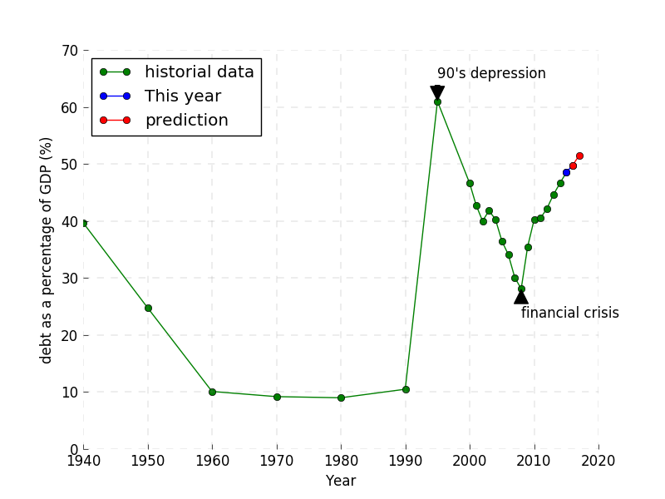

*Figure 4. A proper graphic to visualize the current situation without lying.*

Exercise 4/4

Figure 5 presents trellis plot of wine data with 4 features.

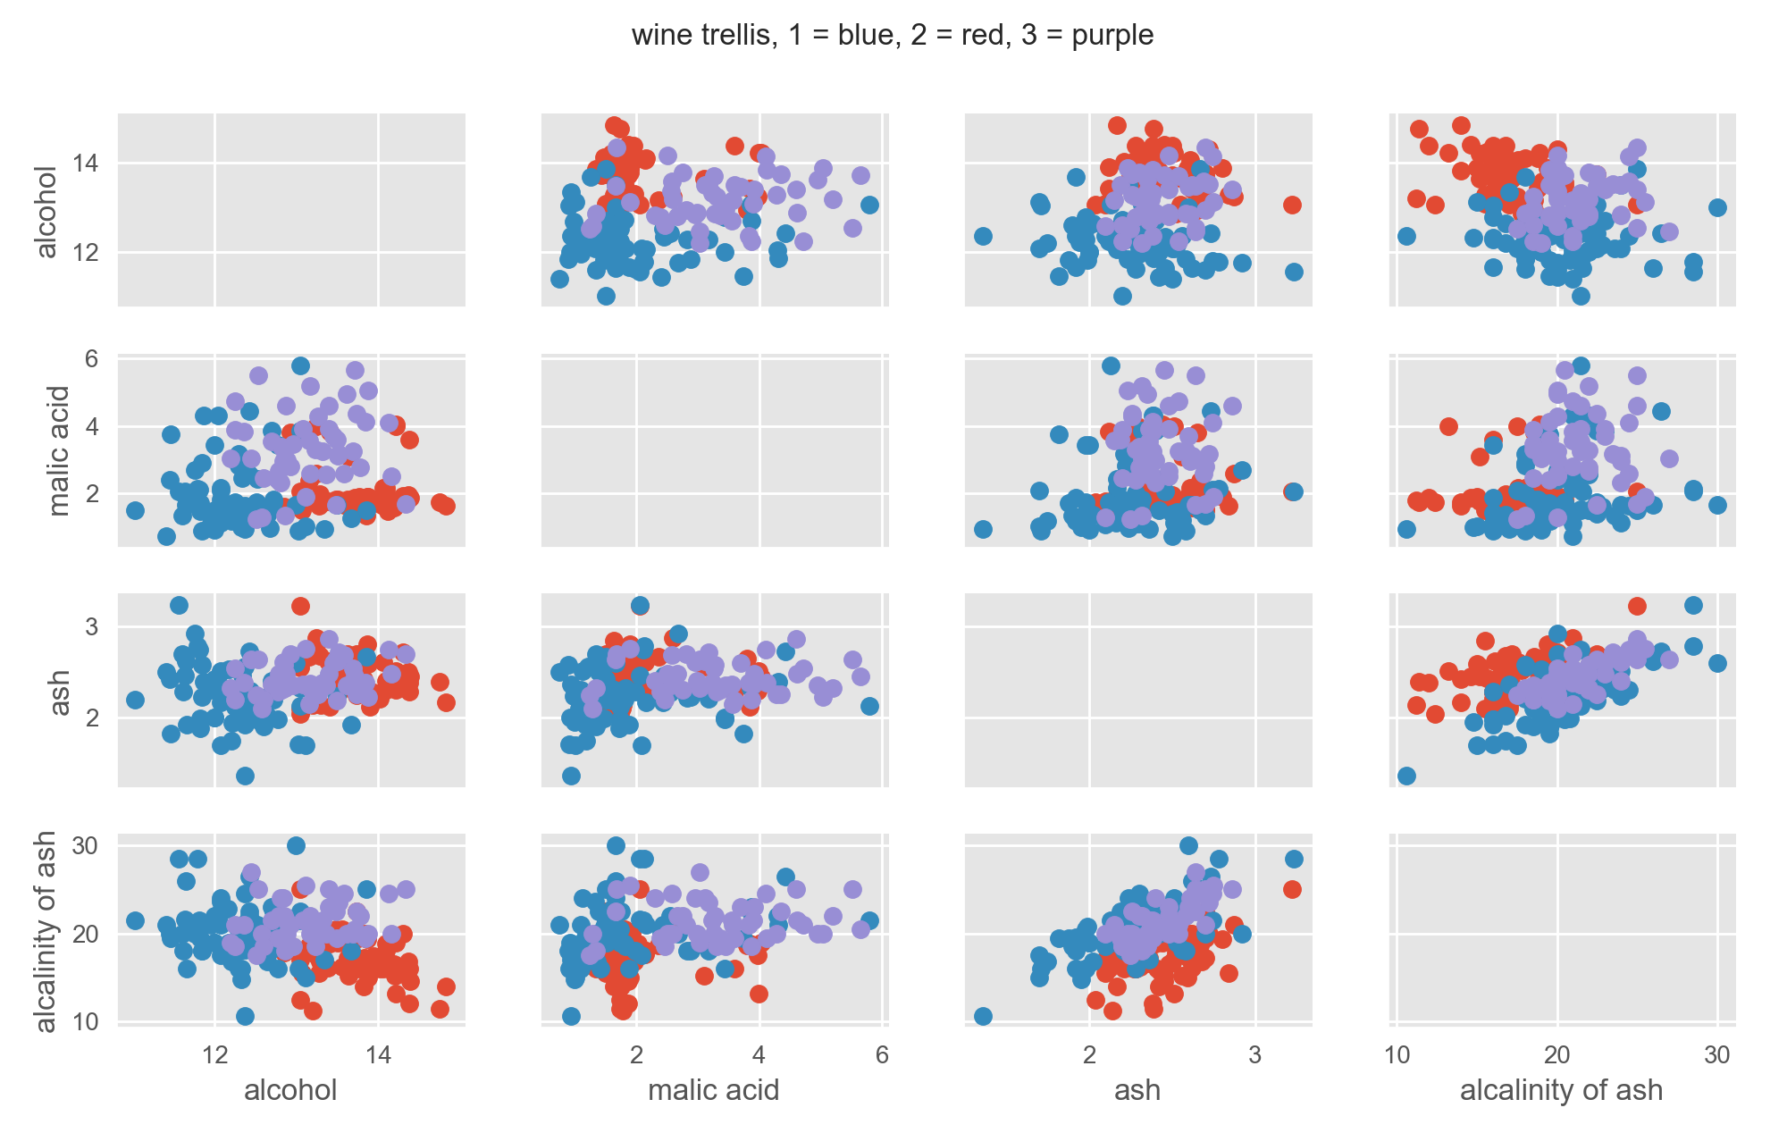

*Figure 5. Trellis plot of wine data’s 4 features.*